**Hello Team!** **Consider the below two tables**:

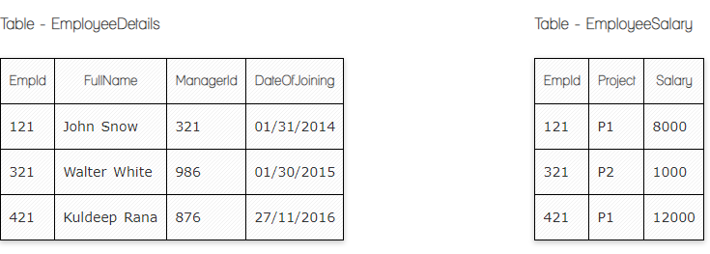

**Ques.2. Write a SQL query to fetch employee names having salary greater than or equal to 5000 and less than or equal 10000.**

**Your Answer:**

**Select** Fullname  
**From** EmployeeDetails **Where** Salary **Between** 5000 and 10000

**Ques.4. Write a query to fetch employee names and salary records. Return employee details even if the salary record is not present for the employee.**

**Your Answer:**

**Select** EmployeeDetails**.**Fullname**,** EmployeeSalary**.**Salary **From** EmployeeDetails **Left Join** EmployeeSalary **On** EmployeeDetails**.**Empid **=** EmployeeSalary.Empid**;**

**Ques.7. Write a SQL query to fetch all the Employees details from EmployeeDetails table who joined in Year 2016.**

**Your Answer:**

**Select** *

**From** EmployeeDetails

**Where** DateOfJoining **Between** '01/01/2016' **And** '31/12/2016';

**Ques.10. Write a SQL query to right join both tables and draw the results.**

**Your Answer:**

**Select \***

**From** EmployeeDetails

**Right Join** EmployeeSalary

**On** EmployeeDetails**.**Empid **=** EmployeeSalary.Empid**;**

|  |  |  |  |  |  |
| --- | --- | --- | --- | --- | --- |
| **EmpId** | **Project** | **Salary** | **FullName** | **ManagerId** | **DateOfJoining** |
| **121** | **P1** | **8000** | **John Snow** | **321** | **01/31/2014** |
| **321** | **P2** | **1000** | **Walter White** | **986** | **01/30/2015** |
| **421** | **P1** | **12000** | **Kuldeep Rana** | **876** | **27/11/2016** |

**Now take these two tables:**

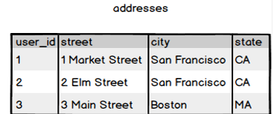

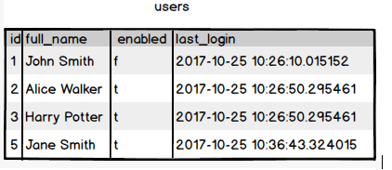

**Ques.11. Write a SQL query to fetch all users full_name from San Francisco.**

**Your Answer:**

**Select** full_name

**From** users

**Inner Join** adresses

**On** users.id=adresses.user_id

**Where** city=' San Francisco';

**Ques.13. Write a SQL query to fetch all users full_name who are not from Main street**

**Your Answer:**

**Select** full_name

**From** users

**Inner Join** adresses

**On** users.id=adresses.user_id

**Where** street!='Main Street';

**Ques.15. Write a SQL query to fetch user full_name who is equal to user_id from Boston (find user_id value in sub_query)**

**Your Answer:**

**Select** full_name

**From** users

**Where** id =

(**Select** user_id

**From** adresses

**Where** city='Boston')